**Guidance Document - Neighbourhood CIL (NCIL) Bidding process**

This document is designed to aid project managers (PMs) wishing to bid for Neighbourhood CIL funds for relevant (community) projects. The bidding process can be split up into **5 PHASES** as outlined below.

**PHASE 1 - EXPRESSION OF INTEREST**

This is the first stage for any potential bidder and comprises an online form which will need to be filled out and submitted within one of the Council’s designated NCIL bidding windows (set out on the Neighbourhood Portal).

Forms submitted AFTER this designated bidding window has closed will NOT be accepted, and any such bids will not proceed until the next cycle (after 12 months or so).

This expression of interest bidding form is split into 3 sections:

**Section 1 - Pass/Fail Criteria**

This first section comprises 3 important questions to determine whether the project in question would qualify for Neighbourhood CIL (NCIL) funding.

Question 1)

*1) The CIL Regulations require that Neighbourhood CIL (NCIL) be used for the following purposes:*

* *The provision, improvement, replacement, operation or maintenance of infrastructure*

***OR***

* *Anything else that is concerned with addressing the demands that development places on an area.*

*Does your project fall within this definition?*

* *Yes*
* *No*

This refers to the CIL regulations themselves. NCIL is an infrastructure levy designed to cover one off infrastructure costs. Please note the phrase “Infrastructure” generally refers to physical elements/works; certain ‘non-construction/non-physical’ based elements, such as digital infrastructure (IT), are not specifically excluded. However, generally funding will not be allocated for the following:

* Feasibility Studies
* Masterplans
* Consultants Fees
* Research and Development
* Marketing (unless integral to the bid).
* (General) Staffing and Training Costs
* Rent/hire costs, bills, overheads
* (General) Fundraising and/or Administrative Costs.
* General/Operational running costs.

It is also expected that all NCIL project bids should be for a fully formed, concrete and costed project.

This sets a wide scope and so it is expected that the vast majority of projects would fall within this definition. However, if the project does NOT fall within this definition, please do NOT continue with the bid.

Question 2)

This Question is split into 3 parts (2a, 2b and 2c)

2a) Are you a constituted group, organisation, business or charity?

* Yes
* No

The above should be fairly self explanatory.

2b) If you answered ‘Yes’ to Q2a), please provide your Registration Number or Equivalent.

In most cases, the Company Registration Number would be put here. However, alternatives could include things such as the following:

* Charity Registration Reference
* HRMC Community Sports Club Registration

If you are a School, Higher Education Facility, or other public body (eg a Council department) then you don’t need to provide a registration number.

The Council wishes to encourage as many different groups and bidders as possible to come and bid for NCIL money for valuable not-for-profit community projects. However, at the same time, it must ensure to the best of its ability that any bidders given money have the expertise and ability to deliver the projects which they are bidding for, and that those receiving public funds can be held accountable. As such, the Council will expect any bidder to be able to demonstrate the following as set out within Question 2c (below):

2c) Are you able to demonstrate all of the following (where applicable)?:

1. That your group has a management committee or board of trustees with at least three members.

2. You have a bank or building society account in the name of the group/ organisation.

3. That you do not have an ongoing deficit that the NCIL grant application could be used to fill.

4. That your group has at least two unrelated people to authorise cheques and/or make withdrawals.

5. That you have an accounting system record income and expenditure (please provide a copy of your annual accounts).

6. That you have a budget breakdown form for the project/service you want to undertake.

If you CANNOT provide this information, then please do NOT continue the bid. Please note that you do not have to provide the information itself at this stage.

NOTE: If you are a smaller community group who is not registered, or is inexperienced and concerned about whether you are able to successfully deliver the intended project, then you **may** be able to apply in partnership with another constituted organisation and/or liaise with a relevant Council department. Please contact the neighbourhood managers and/or relevant Council Department for further guidance/direction on this.

Question 3)

*3) Will the completed project be subject to additional costs (e.g. maintenance) which are intended to be covered by NCIL?*

* *Yes*
* *No*

NCIL bids are ‘one-off’ payments to deliver projects, and cannot be used to fund ongoing costs, such as those for post completion maintenance. As such, if you answered YES to this question, please do NOT continue with your bid.

**Section 2 - Further Project Details**

Questions 4) to 9)

*4) Name of Bidding Organisation*

*5) Name of the primary project contact (for us to contact in the first instance)*

*6) Postal Address of Bidding Organisation (including postcode)*

*7) Email address of Primary contact*

*8) Telephone/Mobile of Primary contact*

*9) Project Site Address(es) (if different from above)*

These questions are considered to be self explanatory/straightforward, and so no further guidance is considered necessary.

Questions 10) and 11)

*10) Value of NCIL Funding Sought (£)*

Please provide a figure on the amount of NCIL funding sought (NOT the full project costs). Please be aware that funding pots vary between each neighbourhood and from cycle to cycle. Guidance on the estimated budget for this round for each neighbourhood is provided on the Lets talk NCIL page. Larger bids are permitted but will likely attract more scrutiny and may not be able to be funded due to budget constraints.

*11) Project Description (No more than 200 words)*

Please provide a **brief** description/overview of your project. Note that there will be an opportunity to provide much greater detail, including proposed plans/other supporting documentation further along the process (in the Project Bid Report).

*12) Desired Project Outcomes (Summary)*

Please briefly outline the desired project outcomes. Note that there will be an opportunity to provide much greater detail further along the process (in the Project Bid Report).

**Section 3 - Policy Objectives, Costs and Funding**

In this section, there are a number of questions which refer to different aspects, such as Neighbourhood Plans, the council’s Infrastructure Delivery Plan, match funding (etc).

Questions 13a) and 13b)

*13a) Does your project meet any of the relevant “Priorities/Objectives” set out in the relevant Neighbourhood Community Plan? To find out what neighbourhood your project lies in, please use our online map available* [*here*](https://kingston.statmap.co.uk/map/map.html?login=public&password=&map=%5CMaps%5CKingston%5CGallery%20Maps%5CAdministrative%20Boundaries)*. Community plans for the relevant neighbourhood areas are available* [*here*](https://www.kingston.gov.uk/neighbourhood-community-safety/community-plans)

*13b) If you answered "Yes" to the last question, please set out (briefly) what Neighbourhood objectives your project is in compliance with (and how)? NB: There will be an opportunity to explain this in greater detail in the next stage of the process.*

In this question, PMs are asked to briefly identify if the project in question meets any of the Objectives set out within these Neighbourhood Plans (and how). The Neighbourhood Plans are available at the link below:

https://www.kingston.gov.uk/neighbourhood-community-safety/community-plans

Questions 14a) and 14b)

*14a) Does your project contribute towards any of the projects set out in the Council’s (Draft) Infrastructure Delivery Plan (IDP). NB: The Draft Infrastructure Delivery Plan is available here.*

*14b) If you answered "Yes" to the above, please indicate which project below, how this project contributes, and state what tier this project lies in (either Critical, Essential or Important)*

The Council has developed an Infrastructure Delivery Plan (IDP) which sets out the Council’s strategic infrastructure priorities. Details of the plan, including the plan itself, can be found [here](https://kingstonletstalk.co.uk/other-supporting-documents). In this question, PMs are asked to identify if their project contributes to any of the projects identified in the IDP.

The projects have been grouped together by ‘service area’ and are listed at the end of each section in the IDP as shown in the example below (Education section). The tiers are colour coded as follows:

* Critical - Red (Tier 1)
* Essential - Orange (Tier 2)
* Important - Yellow (Tier 3)

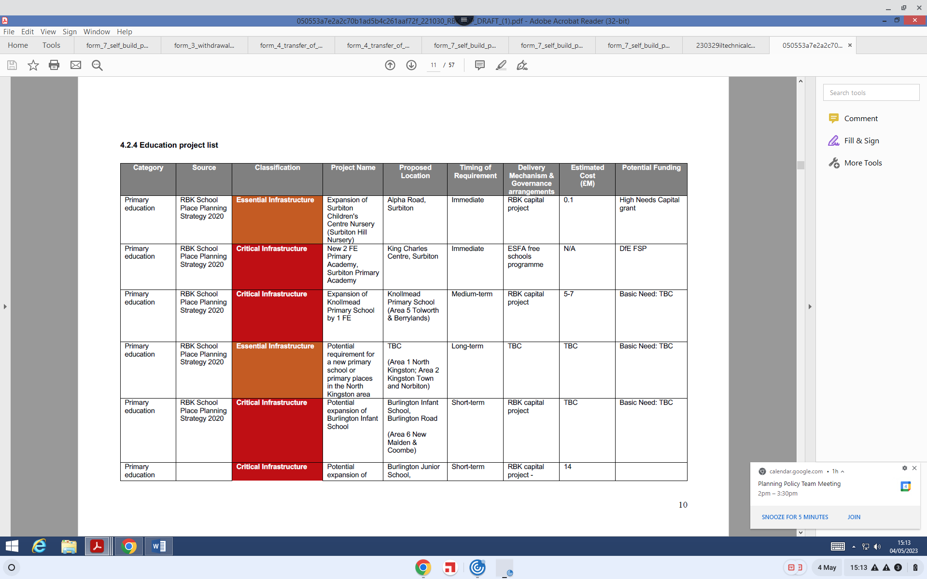

Questions 15a) and 15b)

*15a) Is the Project being match funded?*

*15b) If you answered 'yes' to the above, please describe/provide details of the match funding amount, the source of this funding and whether this has been secured as of the time of writing.*

These questions are designed to identify if the project has match funding lined up, where this is from and whether or not this has been secured.

Questions 16a) and 16b)

*16a) Would the project result in additional costs to the Council post completion? (eg for maintenance).*

*16b) If you answered 'yes' to the above question, then please provide brief details and estimates of these costs (where applicable).*

These questions are designed to identify what costs to the Council could potentially arise post completion of the project.

Question 17)

*17) What is the Index of Multiple Deprivation (IMD) Decile value of the site in which the project is based? (If project covers multiple sites, then use the LOWEST value)*

*(IMD Decile value is available for viewing* [*here)*](https://data.kingston.gov.uk/deprivation/map/) *- please see guidance document for additional help with this question.*

* 9-10
* 7-8
* 5-6
* Below 5

This question is designed to identify the level of deprivation where the project is located (where relevant). Please note that the IMD Decile value of the project site can be found using the method below:

1. Visit this website - <https://data.kingston.gov.uk/deprivation/map/>
2. On the left hand side, click on Index of Multiple Deprivation (IMD) Decile (noagg) - outlined in red below
3. Enter the address of the site in the box in the bottom right hand corner of the map -outlined in yellow below

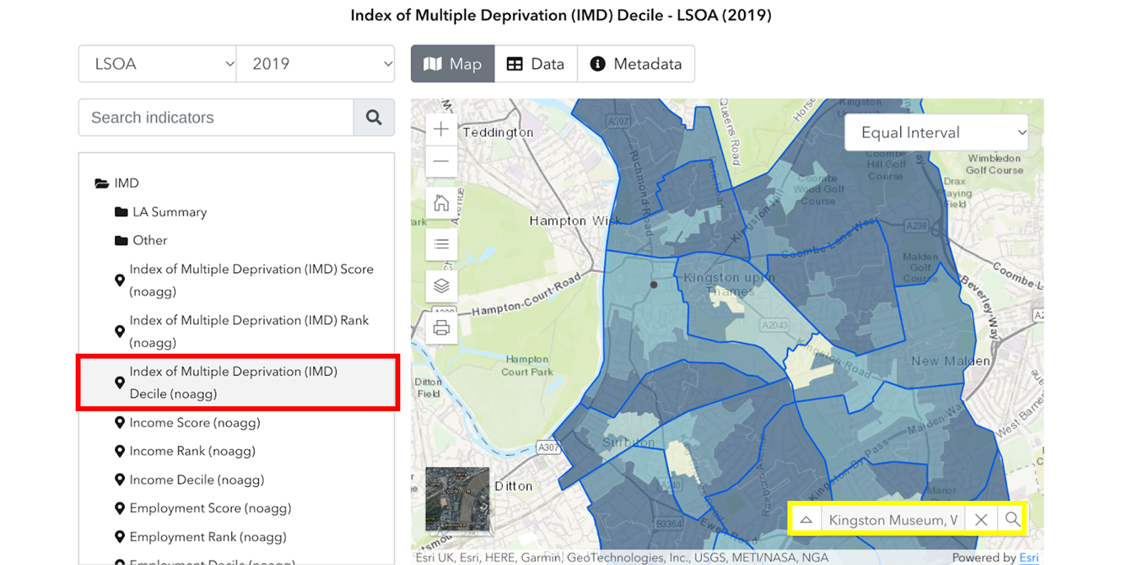

1. Click on the project site location on the map
2. A window will pop up and the IMD Decile value will be shown as below (circled in green)

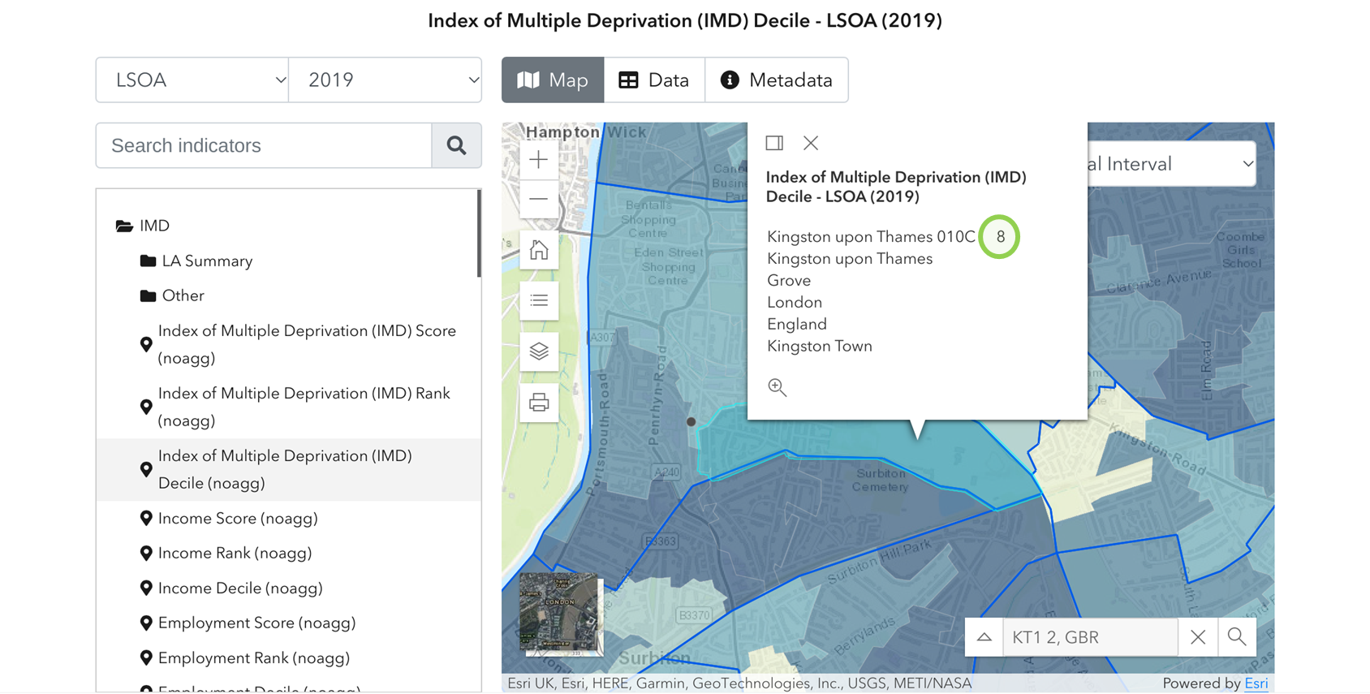

1. Answer the question based upon this value.

If you are having trouble with this question (or any others), please email the below:

[neighbourhood_management@kingston.gov.uk](mailto:neighbourhood_management@kingston.gov.uk)

Once these questions are completed, please submit the form.

**PHASE 2 - PROJECT BID REPORT**

Once the expression of interest form has been submitted satisfactorily, the bid will be allocated to and reviewed by the relevant Neighbourhood Manager. Following this, PHASE 2 will begin.

Neighbourhood managers will send out the template bid report to bidders at the beginning of this phase. This template report will also be available for download from the Lets Talk NCIL homepage (Right hand side) [The template report is also available here](https://kingstonletstalk.co.uk/ncil)

Sections/Text highlighted in yellow are to be filled in by Project Manager (PM) seeking NCIL funding.

Sections/Text highlighted in green are to be filled in by Neighbourhood Managers upon receipt of the report from the PM.

A fair amount of guidance is provided within the project bid report template itself, which won’t be repeated here, though some additional guidance on public engagement is provided below:

**Public Engagement/Consultation**

The Council will expect bidders to undertake ***proportional*** public consultation/engagement on the majority of NCIL funding bids. In essence, the greater the amount bid for, the greater level of consultation that would be expected to be undertaken.

Guidance on how to undertake public consultation and how to report the results will be made available on the Neighbourhood Lets Talk Portal in due course.

Presentation of the results and explanation of how the results impacted upon/shaped the final proposal can/should also be provided in this section of the report.

NOTE: No formal consultation is required for the small scale projects - known as ‘micro-schemes’ (below £5k). However, any voluntary consultation undertaken on these schemes will likely work in favour of these proposals.

If you have any questions or queries when completing this report, please send these to the email address below and the relevant Neighbourhood Manager will respond in due course ( within 10 working days).

[neighbourhood_management@kingston.gov.uk](mailto:neighbourhood_management@kingston.gov.uk)

To find out what neighbourhood your proposal is in, please click [here](https://maps.kingston.gov.uk/maps/MapPage.aspx?map=adminBoundaries)

Once the report has been completed, this will need to be sent to the email address above BEFORE the dates set out on the Neighbourhood Portal (and Bidding Process Schedule Document). Reports received after this deadline will **not** be considered.

The neighbourhood managers will then check the project bid reports, add the other related information and prepare them for PHASE 3 - COMMITTEE DECISION.

**PHASE 3 - COMMITTEE DECISION**

At Kingston Council, decisions on the allocation of NCIL will be made by the Councillors at their associated Neighbourhood Committee meeting.

Internal workshops between Council Officers and Members of the Neighbourhood Committees will occur before the relevant neighbourhood (decision) committee meeting(s) in order to go through the bids in more detail, discuss NCIL finances/income and identify any key questions/issues to be directed to the PMs. Any questions/issues for PMs arising from these workshops will be fed back after these workshops (and before the Committee dates), to allow PMs to act/respond.

Project managers will be expected to attend the Committee meeting itself to answer these questions and/or take further questions from Councillors. Councillors will discuss all the bids at the meeting and will then make a final decision on which (if any) projects to allocate NCIL funds to at the meeting itself.

All NCIL approvals granted by the Committees will be time limited as explored in PHASE 4 below. This is to ensure that approved projects are delivered in a timely fashion, and that NCIL monies allocated from projects that are not delivered in a timely manner can potentially be reallocated to other projects.

**PHASE 4 - POST DECISION**

If a project manager from an external organisation is successful with the bid, they will be expected to sign a simple agreement before any funds are released. This agreement will be (principally) designed to secure the following:

* The use of the funds for the approved purpose(s) within the set timeframe.
* The return of unspent funds to the Council.
* Provision of monitoring/reports on project progress (usually bi-annually).

Once this agreement has been signed and returned, the funds can then be released.

If you are unsuccessful with your bid, then you are welcome to bid again in the next NCIL bid window if so desired, or alternatively explore other sources of funding (such as community grants).

**PHASE 5 - MANAGEMENT AND MONITORING**

Internal and external bidders are required to report back as per the agreements set out in PHASE 4. A standard template is provided on the Let’s Talk Website for bidders to use/fill in when reporting back.